

**Documentation**

to HWE exercise

***Step-Up Converter***

|  |  |  |
| --- | --- | --- |
| Group / Class | Employee | Signature |
| 7 / **3BHEL** | **HIRSCH L.** |  |
| Delivery date | Employee | Signature |
| 10th Jan 2014 | **HOFSTÄTTER A.** |  |
| Teacher | Employee | Signature |
| Tillich |  |  |
| Grade | Employee | Signature |
|  |  |  |
| ***Device Under Test***  ***Step-Up Converter*** | | |
| **Used Devices**   |  |  |  |  | | --- | --- | --- | --- | | Nr. | Device | Manufacturer | Type | | 1. | **Power Supply** | **EMG** | **18135** | | 2. | **Digital Multimeter** | **TE.Electronic** | **VA18B** | | 3. | **Oscilloscope** | **Tektronix** | **TDS 1001B** | | 5. | **Function Generator** | **HAMEG** | **HM8030-6** | | | |

ÜBUNGS-/ABGABE-DATUM

Klasse /Gruppe

NOTE

LEHRER

# Contents

1 Contents 2

2 Tasks 3

3 Basic concept of a Step-Up Converter 3

3.1 MOSFET 4

3.2 NE555 as an astable multivibrator 4

4 Dimensioning and Calculations of the Step-Up Converter 5

4.1 Given Values 5

4.2 Period Time () 5

4.3 Pulse Time ( and ) 5

4.4 Inductivity () 5

4.5 Capacitor () 5

4.6 Resistors ( and ) 6

5 Step-Up Converter with fixed Output Voltage (18 V) 7

5.1 Measurement Setup 7

5.1.1 Simultaneous measure of voltage with an oscilloscope 7

5.2 Measurement Results 8

5.2.1 and 8

5.2.2 **Coil** 8

5.2.3 **MOSFET** (Drain-Source) 9

5.2.4 **Diode** 9

5.2.5 10

6 Step-Up Converter with regulation (12 V – 18 V) 11

6.1 Measurement Setup 11

6.2 Measurement results at 12 V (minimum output voltage) 12

6.2.1 **Coil** 12

6.2.2 **MOSFET** (Drain-Source) 12

6.2.3 **Diode** 13

6.2.4 13

6.3 Measurement results at 18 V (maximum output voltage) 14

6.3.1 **Coil** 14

6.3.2 **MOSFET** (Drain-Source) 14

6.3.3 **Diode** 15

6.3.4 15

7 Step-Up Converter with regulation (12 V – 18 V) and Load Regulation 16

7.1 Measurement Setup 16

7.2 Measurement Results 16

7.2.1 Input Signal 16

7.2.2 Output Signal 16

8 Opto-isolator 17

8.1 Measurement Setup 17

8.2 Measurement Results 17

9 Register of Illustrations 18

# Tasks

The given task of this project was to develop a step-up- converter, which would amplify an input voltage of ***12V up to 18V***. The frequency, which had to be used, was 110 kHz.

The individual components (e.g. the inductor and the capacitor) had to be calculated with the given values. The inductor had to be coiled according to the calculated value and the capacitor had to be rounded off to fit the next norm value.

All needed values and component were to be dimensioned and calculated.

After the initial setup and dimensioning the Set-Up Converter was built in different versions on the breadboard

**Versions and possibilities of the Step-Up Converter:**

* Fixed output voltage (18 V)
* Regulation (12 V – 18 V)
  + Load Regulation (dynamic load)
* Regulation (12 V – 18 V) and additional optical isolation of the output
  + Load Regulation (dynamic load)

# Basic concept of a Step-Up Converter

All above mentioned versions are all based on the following basic concept. For a very basic and hypothetical Step-Up Converter only 4 components are needed.

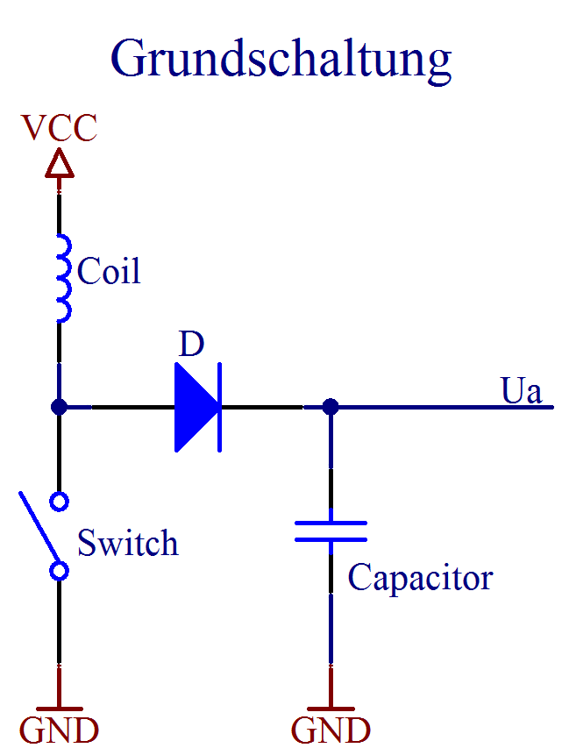

Figure 1. Basic Concept of a Step-Up Converter

* Coil
* Capacitor
* Diode
* Switch (fast switching times)

When the switch gets closed a magnetic field gets inducted in the coil. As soon as the switch is opened up again the coil will do everything to keep the current (that’s because the current trough an coil doesn’t jump). With this current the capacitor is charged.

To prevent discharging of the capacitor a diode is necessary. The diode blocks the current to flow back to the coil. So a higher output voltage is provided.

The switch functionality is mostly brought by a transistor or MOSFET which is toggled with a high-frequency rectangular signal. This provides fast switching times on the MOSFET.

In this project a MOSFET, which is connected through an astable multivibrator (NE555 in this case), is used to provide the switch functionality.

## MOSFET

The MOSFET (***M***etal ***O***xide ***S***emiconductor ***F***ield ***E***ffect ***T***ransistor) can, as mentioned above, be used as a switch.

To implement this, the MOSFETs **Gate** were connected to the NE555s output where the rectangular signal is provided. The **Source** were connected to ground and **Drain** led to the node which splits to the diode and the inductor. This way it functions as the intended switch in Figure1.

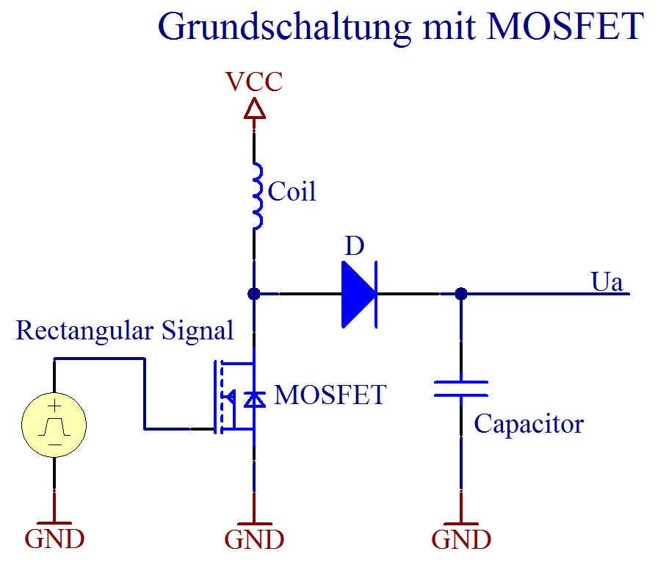

Figure 2. MOSFET as Switch

That’s necessary because a MOSFET can handle much more current (between Drain and Source) than the output of a NE555 (e.g. the output current is about 50 mA).

|  |  |
| --- | --- |
| http://upload.wikimedia.org/wikipedia/commons/thumb/a/a6/TO-220_Front_Coloured.svg/2000px-TO-220_Front_Coloured.svg.png  Figure 3. TO-220 case of the MOSFET | http://upload.wikimedia.org/wikipedia/commons/thumb/6/62/IGFET_N-Ch_Enh_Labelled.svg/2000px-IGFET_N-Ch_Enh_Labelled.svg.png  Figure 4. MOSFET circuit symbol |
|  |  |

## NE555 as an astable multivibrator

For the rectangular signal which is responsible for switching the MOSFET is provided by a NE555. Its big advantages are that the IC is completely integrated in the circuit. So no additional power supplies or external function generators are needed.

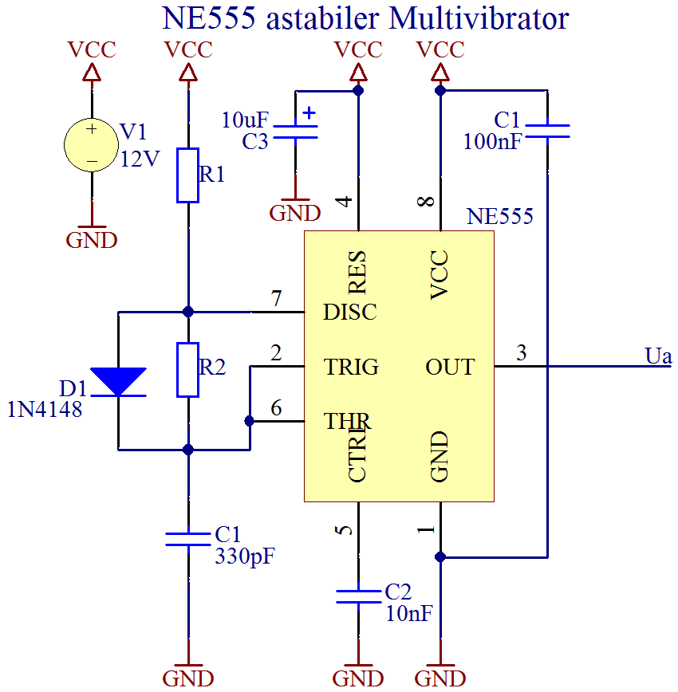

Figure 5. NE555 as an astable multivibrator

Also a positive aspect is that it is also supplied by a direct current source which could be up to 16 V.

The frequency and pulse width depends on the values for R1, R2 and C1. These three components should be adapted to change the output signals parameters.

Since the frequency determining capacitor was given as fixed value only both resistors need to be calculated based on the other given values in the task.

# Dimensioning and Calculations of the Step-Up Converter

## Given Values

The following values were part of the given task and thus set.

## Period Time ()

Based on the given frequency the period time was calculated.

## Pulse Time ( and )

With this result, the time of the positive and negative amplitude produced by the NE555 were reckoned.

## Inductivity ()

To calculate the inductivity the maximum current needs to be determined first.

Then it was possible to determine the needed inductivity.

Which ultimately led to the inductor, which had to be coiled after calculating the amount of windings. The inductance constant of the coil was also part of the task and was given with the amount of .

## Capacitor ()

The Capacitor for the step-up converter was calculated with the following formula.

To fit the norm standard, the capacitor was normed to the value.

## Resistors ( and )

The resistors R1 and R2, which determine the frequency of the astable multivibrator rectangular signal, had to be calculated to fit the allegations.

These resistor values got normed to fit the E12 standard.

# Step-Up Converter with fixed Output Voltage (18 V)

## Measurement Setup

The following schematic shows the setup for the first measurement, there are also some capacitors for stabilization and smoothing.

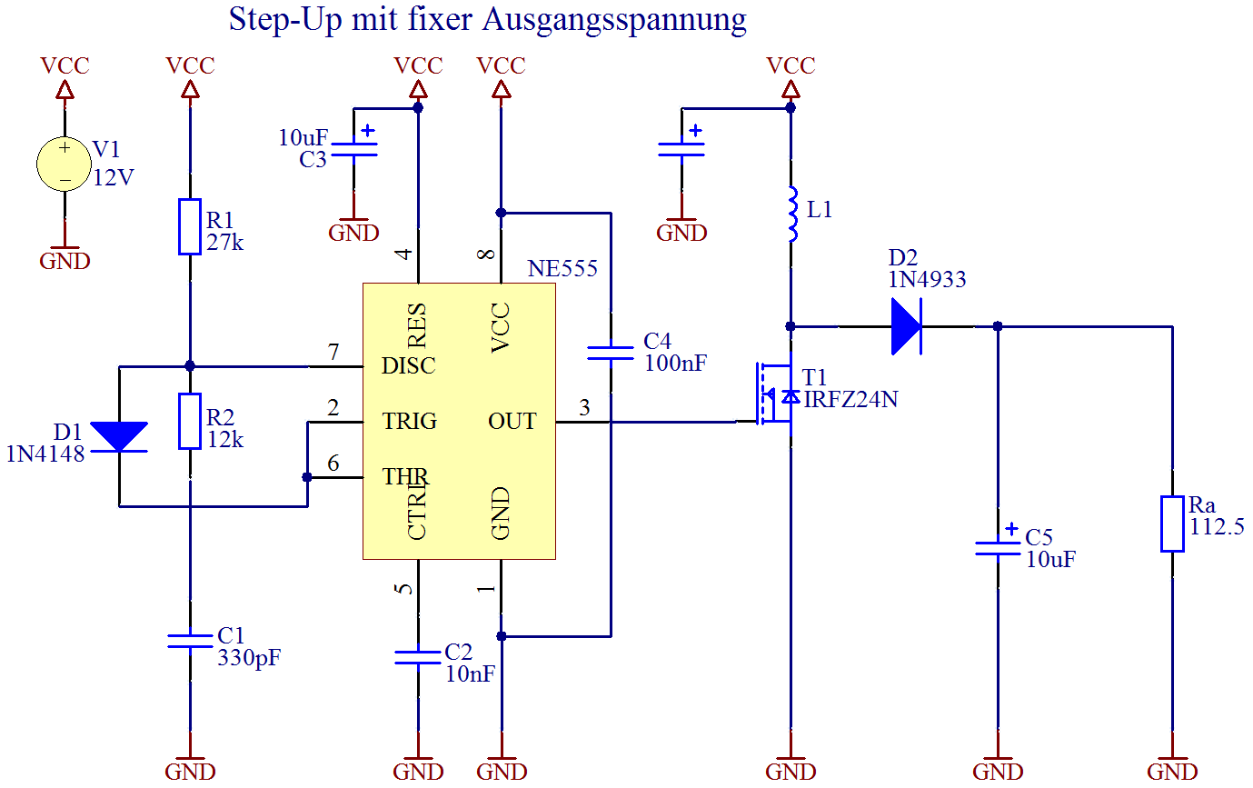

Figure 6. Complete circuit with fixed output voltage

To increase the maximum power of the resistance () the total resistance consist of 6 individual resistors. These were connected as followed.

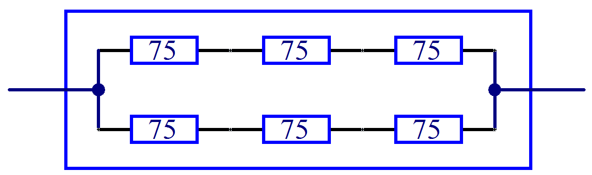

Figure 7. Load resistance ()

With this simple trick the maximum power was increased six-fold. The total resistance is

### Simultaneous measure of voltage with an oscilloscope

To measure current and voltage at the same time a current-measuring resistor with the amount of was used. The factor of U to I is now exactly 1.

With this trick the voltage signal at the resistor proportional to the current signal.

To measure e.g. the current and voltage of the coil the following setup need to be used.

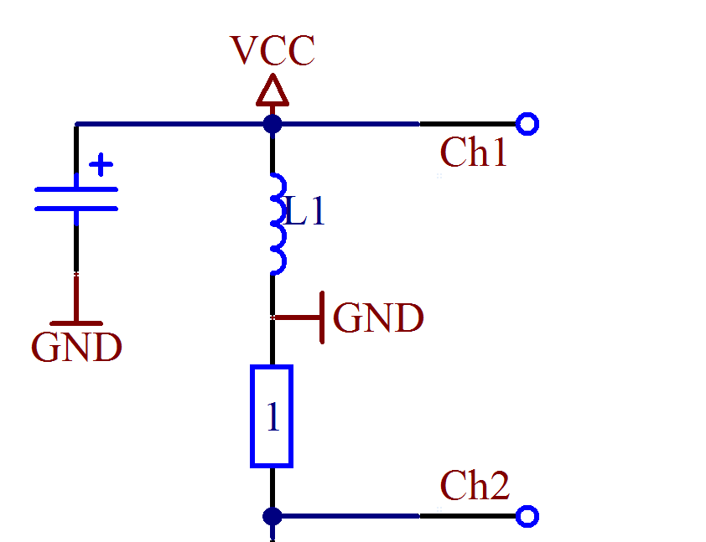

Figure 8. Measurement Setup for oscilloscopes

Ch1 ….. Voltage at the coil   
Ch2 ….. Negative current trough the coil

GND ….. Common measure ground between   
 both measurement points

## Measurement Results

### and

**Ch1: Ch2:**

Figure 9. Measurements on C1 and NE555 output - fixed output voltage

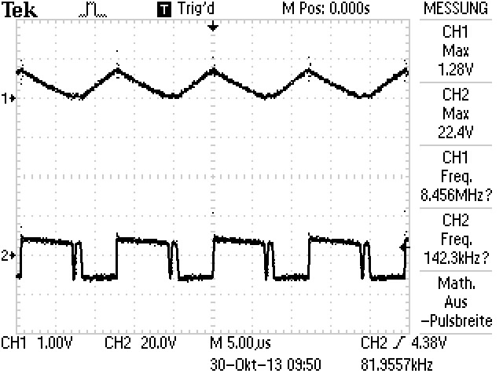

### **Coil**

Ch1: Ch2:

Figure 10. Measurements on the coil - fixed output voltage

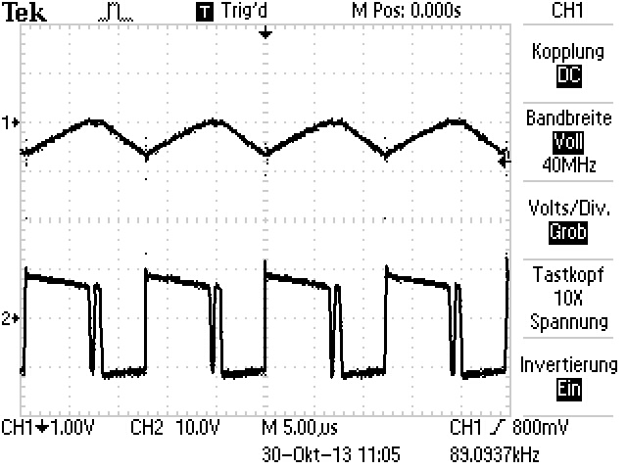

### **MOSFET** (Drain-Source)

**Ch1: Ch2:**

Figure 11. Measurement on the MOSFET (Drain-Source) - fixed output voltage

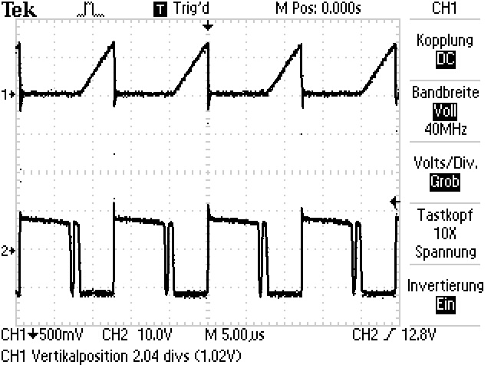

### **Diode**

**Ch1: Ch2:**

Figure 12. Measurement on the diode - fixed output voltage

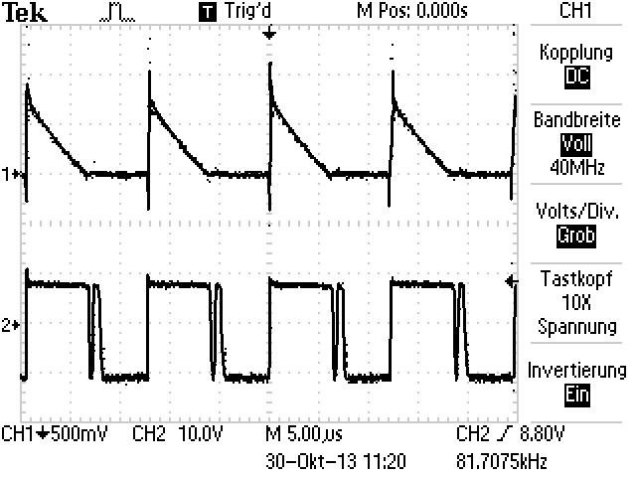

**Ch1: Ch2:**

Figure 13. Measurement on C5 - fixed output voltage

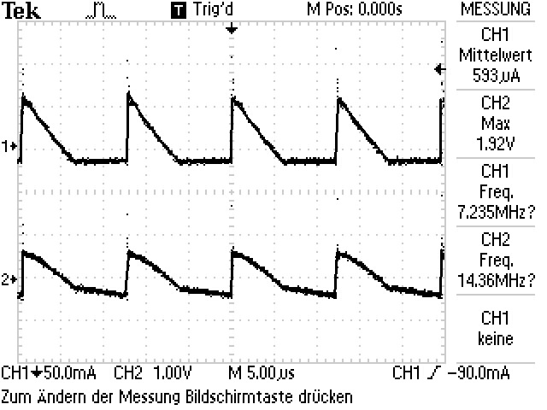

# Step-Up Converter with regulation (12 V – 18 V)

## Measurement Setup

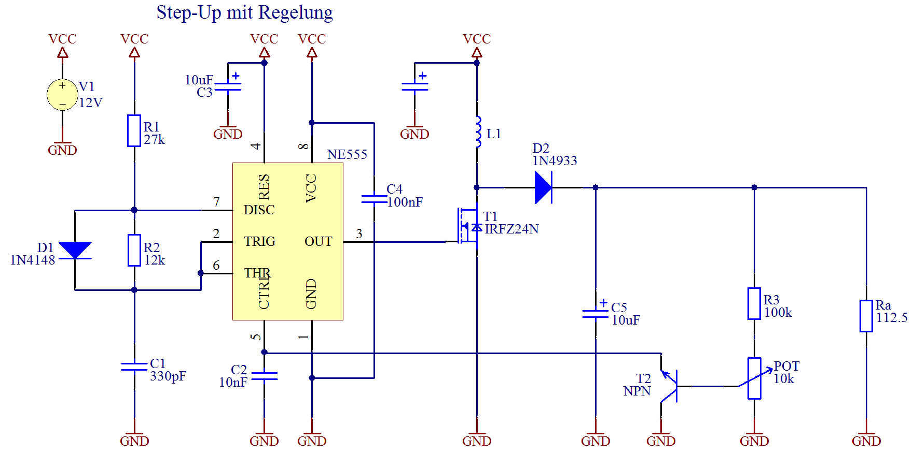

Figure 14. Complete circuit with regulation

With this circuit it is possible to regulate the output voltage from ***Vcc to Ua***. In this case the regulation goes from ***12 V to 18 V***.

This works because at the current extraction from Pin 5 of the NE555 the pulse width of the converter got shortened. Thereby the output voltage decreases and the switching frequency rises up.

## Measurement results at 12 V (minimum output voltage)

### **Coil**

Ch1: Ch2:

Figure 15. Measurement on the coil – regulation (12 V)

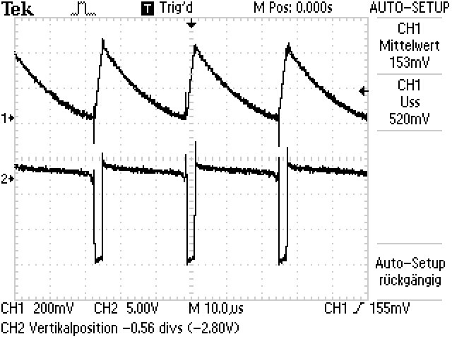

### **MOSFET** (Drain-Source)

**Ch1: Ch2:**

Figure 16. Measurement on the MOSFET (Drain-Source) – regulation (12 V)

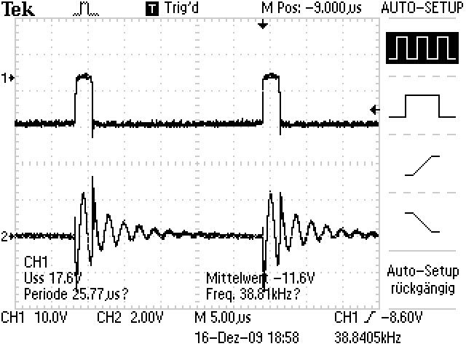

### **Diode**

**Ch1: Ch2:**

Figure 17. Measurement on the diode – regulation (12 V)

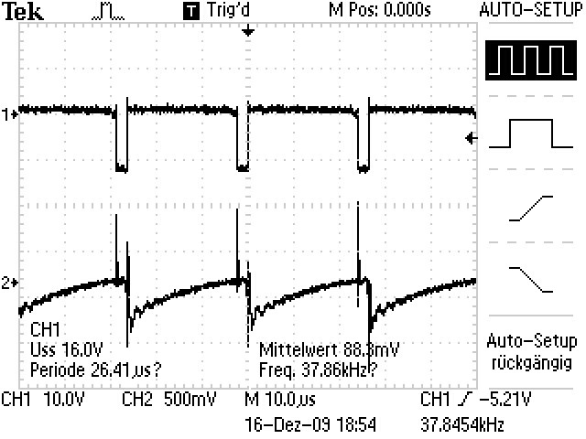

**Ch1: Ch2:**

Figure 18. Measurement on C5 - regulation (12 V)

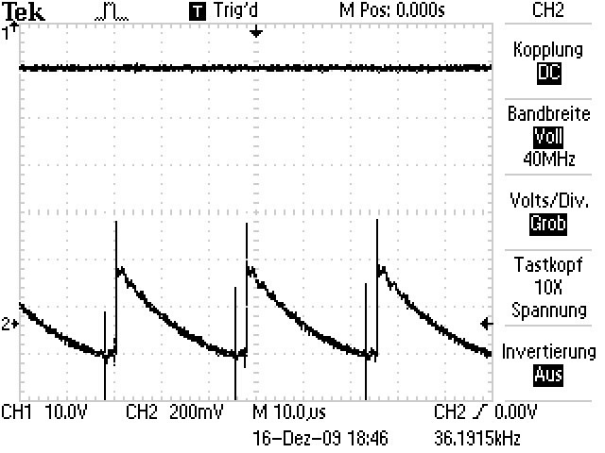

## Measurement results at 18 V (maximum output voltage)

### **Coil**

Ch1: Ch2:

Figure 19. Measurement on the Coil - regulation (18 V)

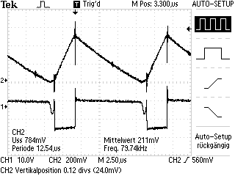

### **MOSFET** (Drain-Source)

**Ch1: Ch2:**

Figure 20. Measurement on the MOSFET (Drain-Source) - regulation (18 V)

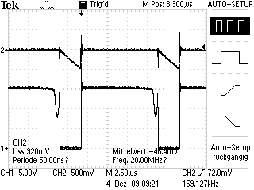

### **Diode**

**Ch1: Ch2:**

Figure 21. Measurement on the Diode - regulation (18 V)

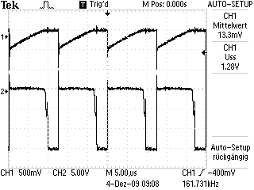

**Ch1: Ch2:**

Figure 22. Measurement on C5 - regulation (18 V)

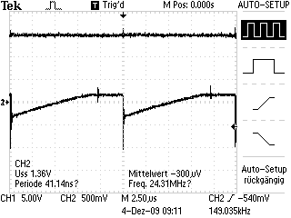

# Step-Up Converter with regulation (12 V – 18 V) and Load Regulation

## Measurement Setup

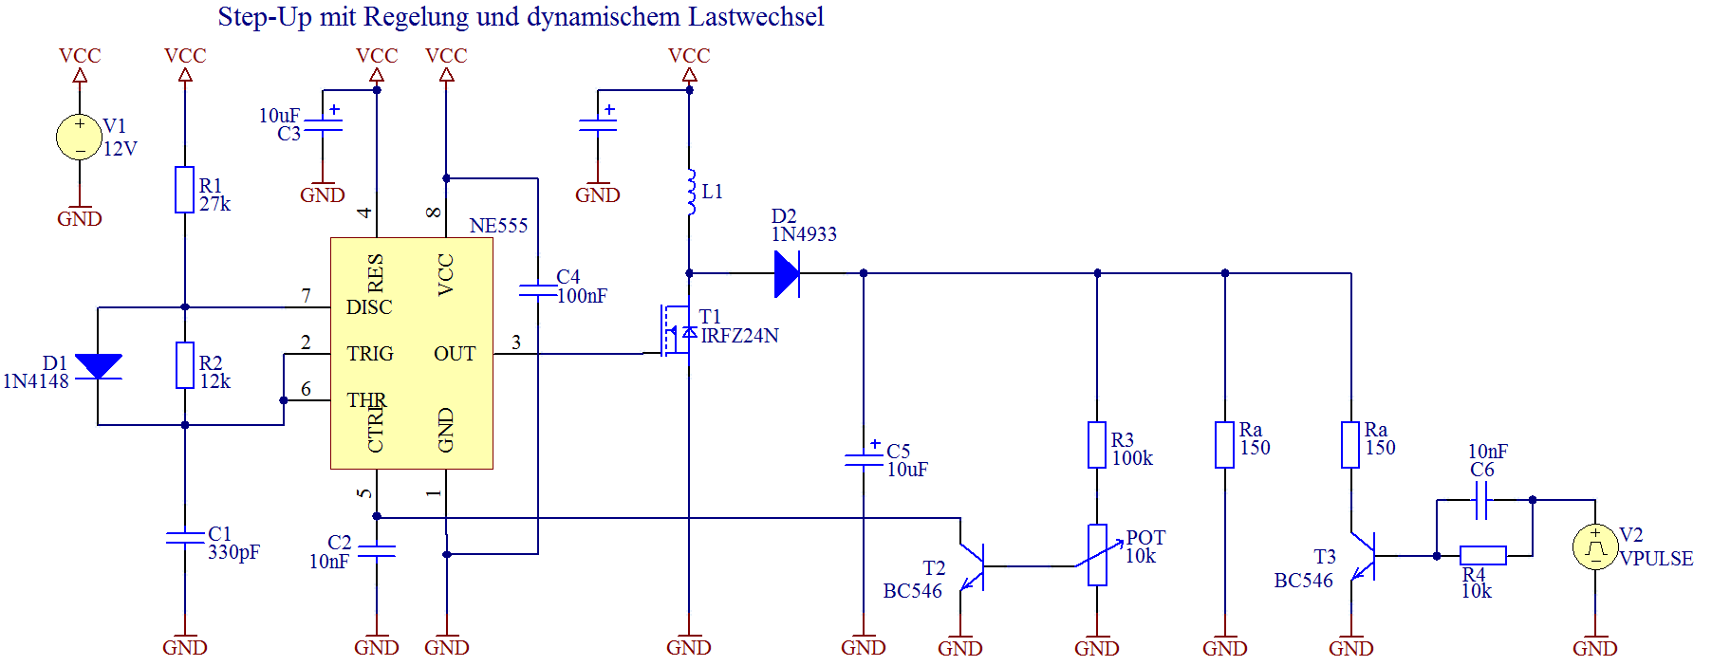

Figure 23. Complete circuit with regulation and load regulation

In this circuit the fluctuations of the output voltage are measured. These fluctuations are results of the temporal discharge of capacitor C5.

Exactly these fluctuations between the load regulation wave generator V2 and the output signal are measured.

## Measurement Results

|  |  |  |
| --- | --- | --- |
| Input Signal |  | Output Signal |
| Figure 24. Input signal of the pulse generator |  | Figure 25. Output signal at the converter |

# Opto-isolator

## Measurement Setup

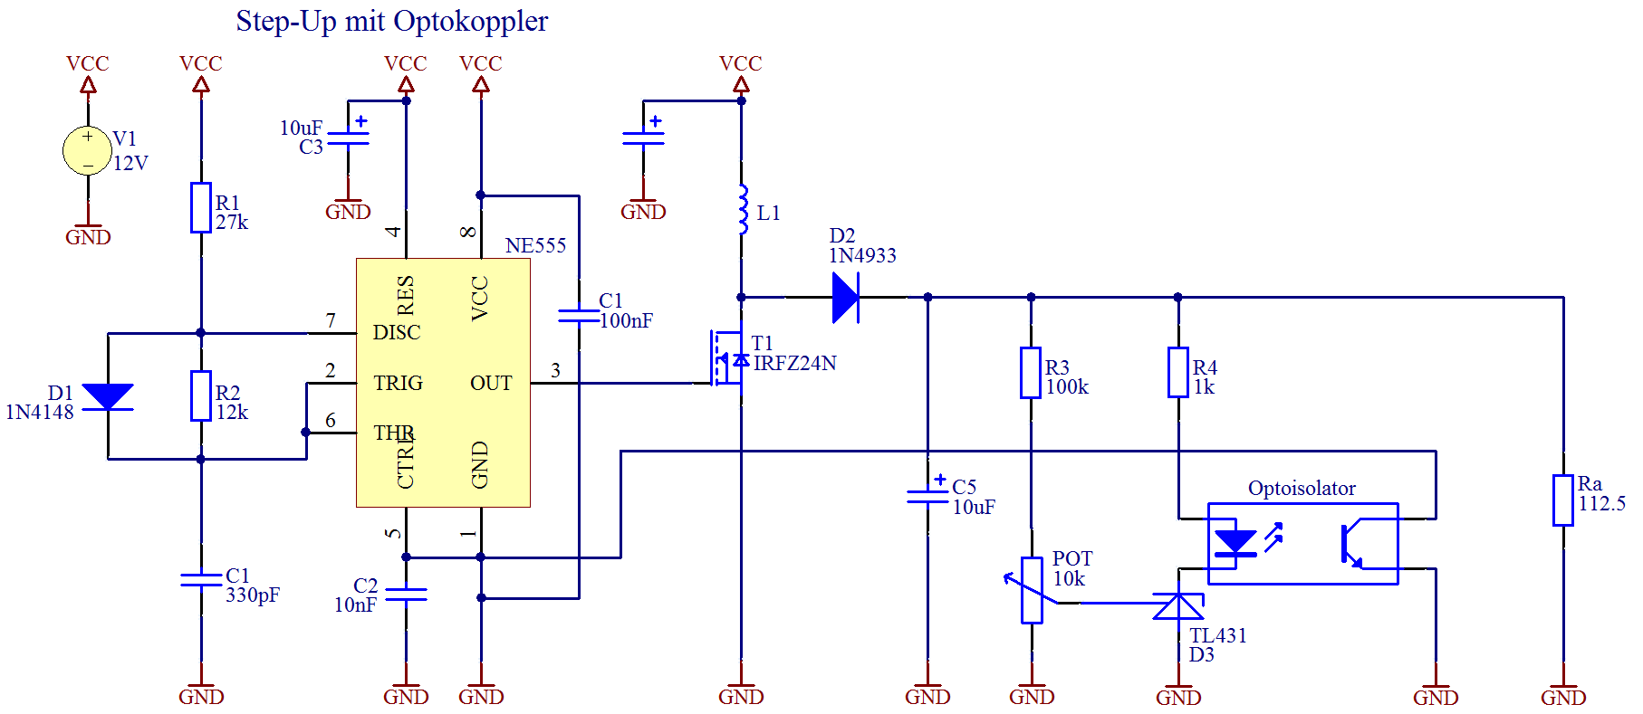

Figure 26. Complete circuit of the regulation with opto isolation

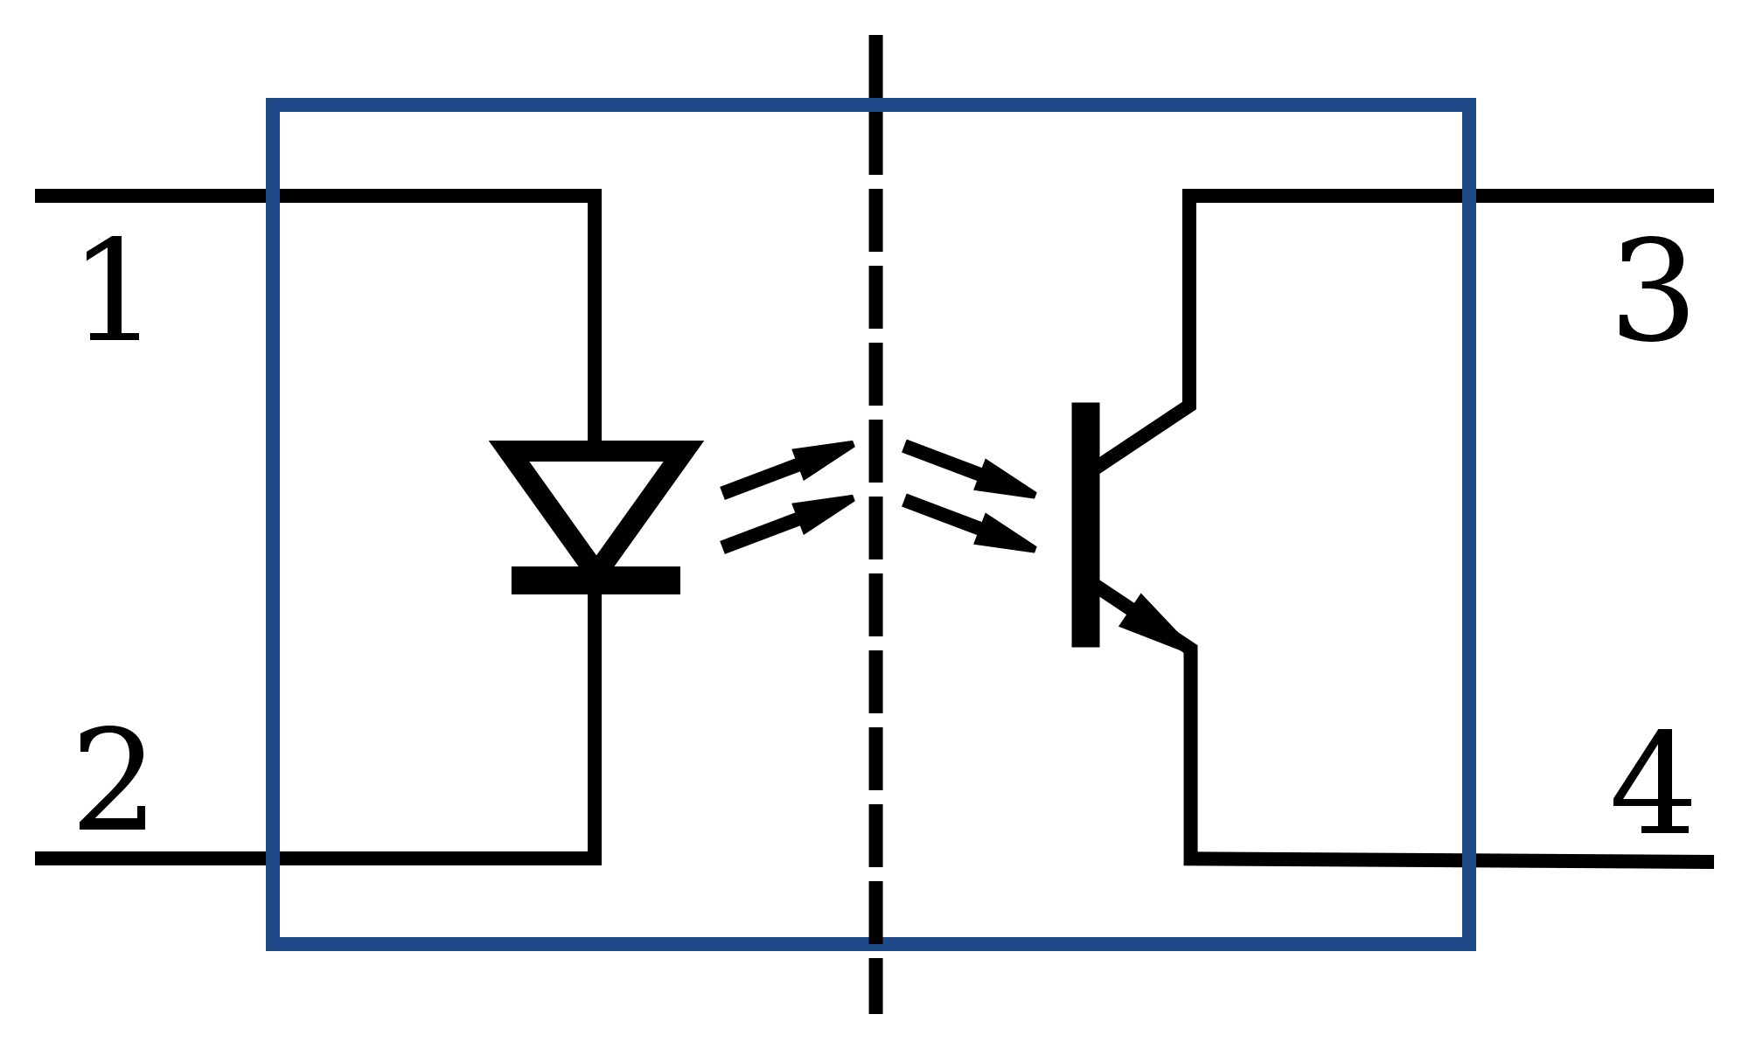

Figure 27. Internal circuit of an opto isolator

An opto isolator separates the output signal from the remaining part of the circuit. An opto isolator consists of a transmitter (IR-Diode) and a receiver (phototransistor). Both parts are integrated in the same chip.

## Measurement Results

|  |  |
| --- | --- |
| Minimal output voltage | Maximal output voltage |
| Figure 28. minimal output voltage – opto isolator | Figure 29. maximal output voltage – opto isolator |

# Register of Illustrations

Figure 1. Basic Concept of a Step-Up Converter 3

Figure 2. MOSFET as Switch 4

Figure 3. TO-220 case of the MOSFET 4

Figure 4. MOSFET circuit symbol 4

Figure 5. NE555 as an astable multivibrator 4

Figure 6. Complete circuit with fixed output voltage 7

Figure 7. Load resistance () 7

Figure 8. Measurement Setup for oscilloscopes 7

Figure 9. Measurements on C1 and NE555 output - fixed output voltage 8

Figure 10. Measurements on the coil - fixed output voltage 8

Figure 11. Measurement on the MOSFET (Drain-Source) - fixed output voltage 9

Figure 12. Measurement on the diode - fixed output voltage 9

Figure 13. Measurement on C5 - fixed output voltage 10

Figure 14. Complete circuit with regulation 11

Figure 15. Measurement on the coil – regulation (12 V) 12

Figure 16. Measurement on the MOSFET (Drain-Source) – regulation (12 V) 12

Figure 17. Measurement on the diode – regulation (12 V) 13

Figure 18. Measurement on C5 - regulation (12 V) 13

Figure 19. Measurement on the Coil - regulation (18 V) 14

Figure 20. Measurement on the MOSFET (Drain-Source) - regulation (18 V) 14

Figure 21. Measurement on the Diode - regulation (18 V) 15

Figure 22. Measurement on C5 - regulation (18 V) 15

Figure 23. Complete circuit with regulation and load regulation 16

Figure 24. Input signal of the pulse generator 16

Figure 25. Output signal at the converter 16

Figure 26. Complete circuit of the regulation with opto isolation 17

Figure 27. Internal circuit of an opto isolator 17

Figure 28. minimal output voltage – opto isolator 17

Figure 29. maximal output voltage – opto isolator 17